vivibosslink.com
Dropshipping with suppliers Fast Shipping

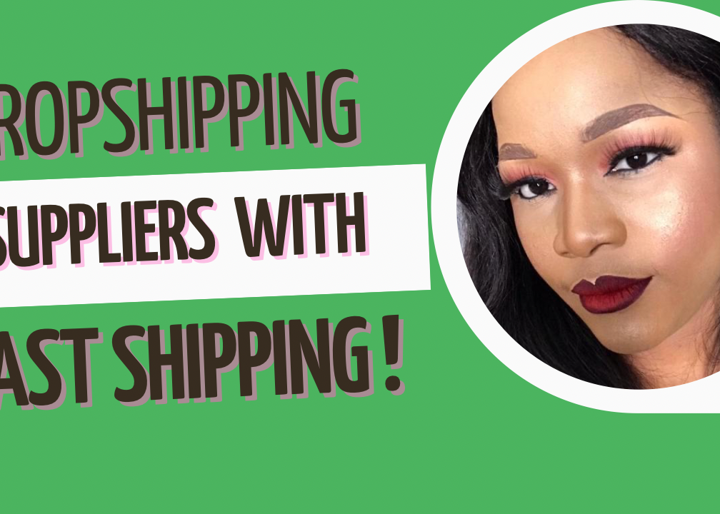

Written Guide

In this article, I’m going to pen down a list of dropshipping suppliers in North America and the EU.

Why use a dropshipping supplier? The benefits of using a dropshipping supplier is fast shipping and private labeling amongst others.

Basically using a dropshipping supplier who is based in the same location as your target audience could mean that you get products delivered to your customers in that location even faster.

Most suppliers also offer private labelling service which means putting your brand on the product packages before they are shipped to your customers.

There are dropshipping suppliers in most countries, your job is to find a winning product then contact suppliers who sell those products.

A quick search on the internet can show you a multiple list of suppliers but they are not exhaustive.

My recommendation is if you find a company that has the kind of product that you want in stock, even if the company does not expressly say that they support dropshipping, do not be afraid to send them an email and propose a dropshipping deal as there is no harm in trying.

How to verify legit dropshipping suppliers

It’s good to be cautious when starting to work with a supplier.

I’d advise ordering a sample product from a supplier “anonymously” to evaluate the quality of their service.

Also it’s recommended to make payment through trusted payment processors that offer buyer protection. For example; PayPal. This is so that if anything goes wrong with the transaction you would be able to file claims or chargebacks to get justifiable refunds.

List of dropshipping suppliers in North America, UK and the EU;

Wholesale2B; it integrates with many ecommerce platforms like Amazon, ebay, Shopify, Ecwid, Woocommerce, Magento, Google, bonanza etc. The platform connects you to suppliers in North America, UK and the EU. Membership access to the platform costs $29.99/per month for the least plan. Their membership allows you to browse their product catalog, import products, automate inventory updates, and 1 click order processing. They handle order and return from the suppliers, make tracking updates etc

Syncee; it’s a B2B platform for Retailers, Dropshippers and suppliers. You can find dropshipping suppliers from the US, EU, AU, and all over the world. It’s easy to find a local supplier with fast shipping on Syncee. There are hundreds of products to dropship on Syncee. They include electronics, clothings, home improvement products and many more!

Syncee has automatic integration with some of the biggest e-commerce platform like Ecwid, Shopify, Wix, Squarespace, Woocommerce, bigcommerce etc

Inventory source; its a directory that connects dropshippers to suppliers in North America, UK and EU. They have a free membership plan as well as premium membership. They provide free supplier directory, US direct sourcing from US based suppliers with 3-4 days shipping within the US, Dropship automation and integration with various e-commerce platform such as Amazon, Shopify, Woocommerce, Ecwid, Ebay, Bigcommerce, Magento, Shift4shop etc

Worldwide brands; This is a directory of wholesalers with suppliers in the USA and internationally, integration with Ebay and Amazon. They claim to be the world’s largest directory of wholesalers. They have a lifetime membership acess fee of $224

Spocket; they automate integration with e-commerce platforms like Ecwid, Shopify, Woocommerce etc. they have a free membership access as well as premium membership. They basically connect Dropshippiers to supplier bases in the USA, UK and the EU. This enables for faster shipping times within those regions.

Printify; this is a global print network connecting you to suppliers in the USA, UK and the EU who offer print on demand services to dropshippers. Basically, if you’re looking to dropship shirts, sneakers, bags, caps etc with your custom graphics designs on them then print on demand services takes care of this for you. The suppliers put your custom graphics in the product before shipping to your customers. Printify is a free network where you can choose from products and suppliers. Printify integrates with many e-commerce platforms like Shopify, Woocommerce, Ebay, Etsy, Wix, Bigcommerce etc

Printful; they also provide print on demand service, optional warehousing and private labelling. Private label means they can send products to your customers in custom branded packages. The shipping time within North America is relatively fast with an Average of 5-7 days shipping. They have Fulfillment centers in the USA, Europe and Australia with fast shipping within these regions. They integrate with many e-commerce platforms including Shopify, Woocommerce, Ecwid, Wix, Esty, Amazon, Ebay, Weebly, Mangento, Shipstation etc. Printful print on demand services is free to use with no monthly fee. You only get to pay for Fulfillment once you get an order.

Zendrop; they offer private labelling, dropshipping, warehousing, product photography and other services. They supply products from the EU and North America across many different categories like beauty, health, hair, outdoor fun, sports jewelry, appliances, bag and shoes etc

Dropship one; they have a free plan and a premium plan. They have integrations with Amazon, Shopify, Ebay, Bigcommerce, Wix, Woocommerce, new egg. The membership gives you access to source products from their directory of suppliers based in the EU and North America. It also manages your inventory and provides trackable shipping options with USPS, Fedex, UPS etc

Knawat; if you are looking to dropship luxury brands from Turkey or luxury brands like Gucci, Versace, Dior, Disney, etc then Knawat could be the plug. Membership starts at $24 per month with a seven days free trial. Membership gives you access to thousands of popular products, Same day or next day Fulfillment, customer support, automation with various e-commerce platforms like Shopify, Ebay, Amazon, Bigcommerce etc

Vika furniture; they are an American based furniture company. They supply custom cushions, drapes, pillows and umbrellas. Basically if you want to Dropship products like throw pillows and give your customers the ability to order custom pillows of various shapes and fabrics, then cushionsource is the way to go. Although they aren’t proactive Dropship suppliers, you can always send them an email and propose a dropshipping deal.

Dropshipping supplier in China

Some of the suppliers on the Chinese platforms have warehouses in other countries like the US and UK, so it's possible to find and negotiate faster shipping with suppliers.

CJ Dropshiping; it has integrations with Ecwid, Shopify, Woocommerce etc. They source products from China’s Taobao and 1688 which are marketplaces where Chinese locals shop. This means that product prices are relatively cheap. They have warehouses in the US from where they can fulfill orders making delivery time to the North America, UK and Europe fast. CJdropshipping also supports Print on demand.

They also provide the services of taking product footages and creating dropshipping video ads for your product. They help to automate dropshipping with a one-click order fulfillment. CJ dropshipping has no set up or monthly fee if the products you want to dropship is available in their US warehouse then you’d only need to pay the cost of the product and shipping.

On the other hand, if you want them to source a product for you that isn’t available in their US warehouse then you’d pay processing fee + shipping fee + warehouse fee.

Aliexpress; It is one of the biggest e-commerce plattfom in the world with thousands of seller from China.Aliexpress is free to access. Most of the suppliers will sell to you even if you want to buy only a single unit of a product.

Aliexpress suppliers offer free worldwide shipping but the shipping times are so long. For example shipping to the US can take more than 4 weeks! The faster shipping portion often with DHL or Fedex comes with a higher shipping rate!

Products are often sold really cheap on Aliexpress! To get faster shipping at an affordable price on Aliexpress! You can filter your search for suppliers with warehouses in your target location. For example, if you want to dropship to the US, you can filter your search on Aliexpress to suppliers that “Ship from” the US.

In this case the product price will be a bit high but shipping will be generally fast and affordable. I recommend you order a sample product from your supplier to validate thier service. Also ordering a sample product has order benefits, For example you cal shoot ad photos and videos with the sample product on hand! You could also grow your buisness social presence by running a giveaway contest with the sample product!

More so, it’s possible to find a supplier on Aliexpress that ship products from China but can offer you faster and affordable shipping options by shipping with faster Chinese shipping lines like 4PX, they could get you 7 to 13 days shipping from China to the United States!

It's also possible to negotiate private labelling with Chinese suppliers on Aliexpress! However for private labelling, where the supplier customizes your product packages to your brand, they’ll usually require a minimum order quantity.

Conclusion

There are many dropshipping suppliers that ship from the EU, UK and North America. Many of these suppliers can be found by looking through the supplier websites listed in this Article.

In any case, if you already know any company that supplies products that you would love to dropship but do not expressly state that they support dropshipping on their website, you can try to email them and propose a dropshipping deal.

There is no harm in trying and if they do not have integrations with your e-commerce platform, you can add them as a staff to your e-commerce store with limited permission. More so, if you aren’t sure that the company or agent is reputable, I will advice you to only pay them through a trusted escrow for example; Paypal Goods and Services.

Happy dropshipping.

FAQ

What if you have an idea of a unique product to dropship but no supplier has it?
If you have an idea for dropshipping a unique item and you’re sure no supplier sells it. You can go to sites like Aliexpress and ask a supplier in your niche, if they can improve an existing product or create a new one to meet your specification. Usually they would require an MOQ (minimum order quantity) to be able to design a new product or redesign an existing one for you. I do not recommend this if you’re only starting to dropship, you should try to source an existing product that you can sell profitably.

Multiple suppliers or a single supplier for a given niche?
It is easier to work with a single supplier than multiple suppliers because communication is faster and you can benefit from the perks that come with selling high numbers like discount offer and net 30 payment much faster with one supplier than when you are splitting orders across multiple suppliers.
It’s allowed to work with multiple suppliers and I encourage it when you are already getting a large number of orders in your store.

Having a main supplier and an alternative supplier for urgent days, is the most recommended option.

Can you use more than one Shopify dropshipping app or would they conflict with each other?
Yes, you can use more than one dropshipping supplier app on Shopify, it shouldn’t conflict but if you experience any issues, you should contact Shopify support.

Can you dropship through any supplier and they automatically get order notification and fulfill it?
Depending on what e-commerce platform you use and what supplier you want to use, there are usually app integration which you can install on your store to automate your order Fulfillment process, however if your supplier doesn’t have any app/plugin integration, most platforms (i.e Shopify, Woocommerce, Ecwid etc) allows you to add the supplier as a staff on your store with order permission, so that whenever you get an order, the Supplier gets an automatic order email notification and can fulfill it.

